Performance Testing

Date | 25 September 2026
Team ID | SWTID-2026-9230
Project Name | LegalEase
Maximum Marks | 5 Marks

Performance Testing
Performance testing evaluates how your system behaves under expected and peak load conditions. Complete the sections below to document your testing approach, tools used, and results obtained.

Step 1: Testing Overview

Field | Details
Testing Tool Used | Postman / manual API timing
Type of Testing | Functional response-time observation / basic load check
Target Module / API | FastAPI document-generation endpoint
Test Environment | Local development environment
Test Date | 25 September 2026

Step 2: Test Scenarios

S.No | Test Scenario / Description | No. of Virtual Users | Duration (sec) | Expected Outcome
1 | Single-user document generation | 1 | 30 | Valid response and generated draft
2 | Repeated generation requests | 5 | 60 | Application remains responsive
3 | Invalid input requests | 5 | 30 | Controlled validation errors
4 | Gemini/API failure scenario | 1 | 30 | Graceful error/fallback

Step 3: Performance Test Results

S.No | Metric | Target Value | Actual Value | Status (Pass / Fail) | Remarks
1 | Response Time (Avg) | < 2 seconds | Not measured | Pending | Actual measurement not provided
2 | Response Time (Max) | < 5 seconds | Not measured | Pending | Actual measurement not provided
3 | Throughput (Req/sec) | To be measured | Not measured | Pending | Load-test results not provided
4 | Error Rate | < 1% | Not measured | Pending | Load-test results not provided
5 | CPU Utilization | < 80% | Not measured | Pending | Host metrics not provided
6 | Memory Utilization | < 80% | Not measured | Pending | Host metrics not provided

Step 4: Observations & Analysis
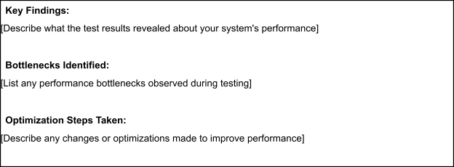

Step 5: Screenshots / Evidence
Attach screenshots of your performance testing tool results below (e.g., JMeter report, Locust graphs, k6 output):


